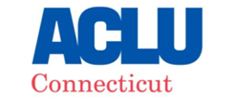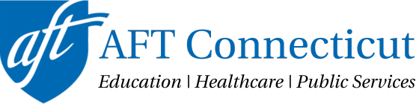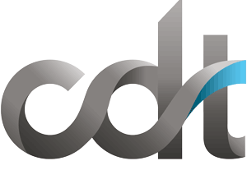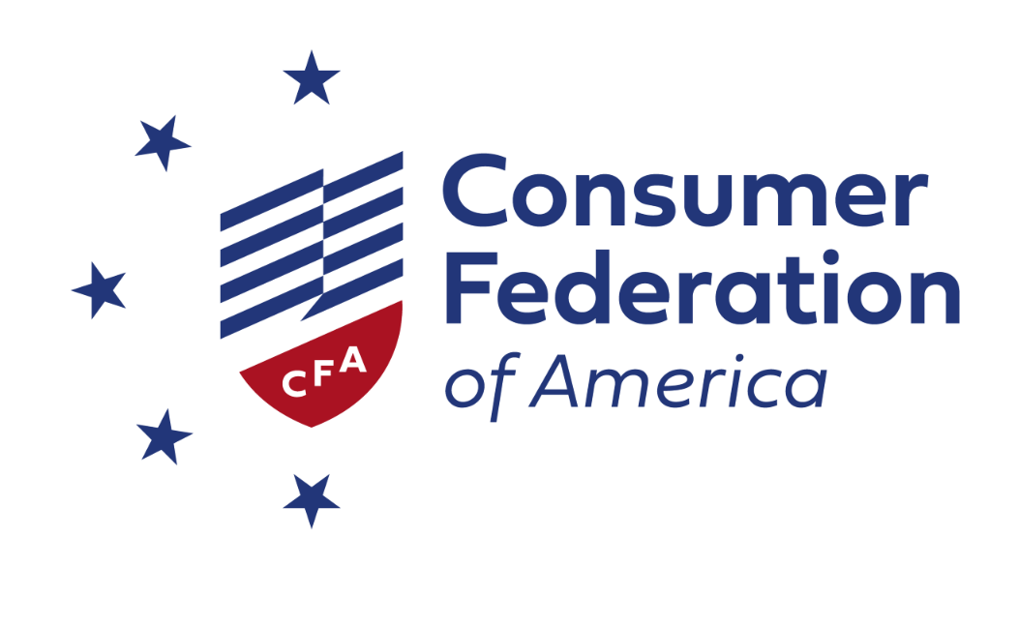

Companies increasingly use AI-driven decision systems to make crucial decisions that alter the course of our lives and careers, often without our knowledge, despite ample evidence that many such systems are deeply biased and flawed. SB 2 would represent a welcome step toward much-needed transparency and accountability for such systems.

However, more is needed to protect Connecticut’s consumers and workers. Policymakers should ensure that the law builds on—and does not undermine—existing civil rights, labor, and consumer protections under Connecticut law.

Policymakers should retain the bill’s strongest existing provisions, including:
- Notice to consumers subjected to AI-driven decisions about the use and purpose of the system;
- Impact assessments that test AI decision systems for discrimination risks and document the AI decision system’s purpose, intended uses, data used and produced, performance, and post-deployment monitoring;
- Detailed documentation requirements for the developers and deployers of AI decision systems and general-purpose AI systems, including documentation on the selection, curation, and evaluation of data used during model development;
- A right to an explanation of the principal reasons behind AI-driven decisions; and
- A right to appeal adverse decisions to a human decision-maker.

Policymakers should also strengthen the law and further protect Connecticut workers and consumers by:
- Clarifying that “consumer” includes Connecticut-based workers;
- Broadening the definition of covered systems so that companies cannot evade the law’s requirements by assigning a human to rubber-stamp algorithmic decisions;
- Building on existing civil rights protections by prohibiting the sale or use of discriminatory AI decision systems;
- Expanding the law’s transparency provisions so that consumers understand why companies are using AI decision systems and what and how these tools measure, including requiring explanations to be actionable;
- Strengthening impact assessment provisions to require companies to test AI decision systems for validity and the risk that they violate consumer protection, labor, civil rights, and other laws;
- Require mitigation of discriminatory harms discovered through impact assessments.
- Eliminating the many loopholes that exclude numerous consumers, workers, and companies from the law’s protections and obligations, as well as unnecessary and overbroad rebuttable presumptions and affirmative defenses that allow companies to escape accountability; and
- Strengthening enforcement by allowing the CHRO and local district attorneys to engage in enforcement and giving consumers and workers the right to seek redress in court when companies fail to comply with the law.
- Clarifying how the law applies to the public sector and ensuring public sector employees enjoy the same rights as private-sector workers under the act.
- Establishing community-based education and training for workers from groups vulnerable to automation, including workers from historically marginalized communities, and a joint labor-management committee to improve state employee AI trainings.
- Giving the Attorney General authority to issue rules interpreting and clarifying the law.

Connecticut played a crucial role in kickstarting the national conversation about managing AI risks in 2024. It has an opportunity in 2025 to lead the nation with innovative policy that places common-sense guardrails on the development and use of AI and automated decision-making systems. We are eager to work with lawmakers to craft AI legislation that both protects the rights and privacy of Connecticut residents and encourages technological innovation.

Signed:
ACLU of Connecticut
AFT Connecticut
Center for Democracy & Technology
Connecticut AFL-CIO
Consumer Federation of America
Consumer Reports
Electronic Privacy Information Center
Hispanic Federation Connecticut State Office
NAACP Connecticut State Conference

